1) Watch terraform-03 video.

2) Execute the script shown in video.

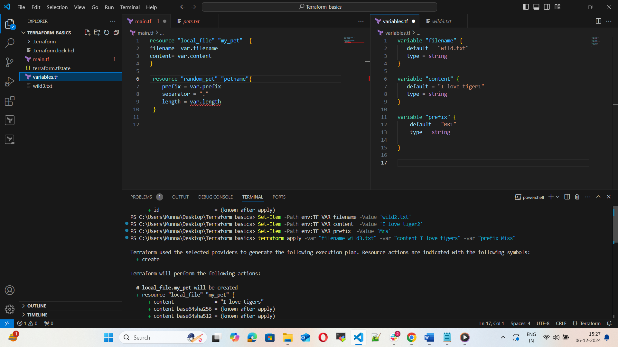

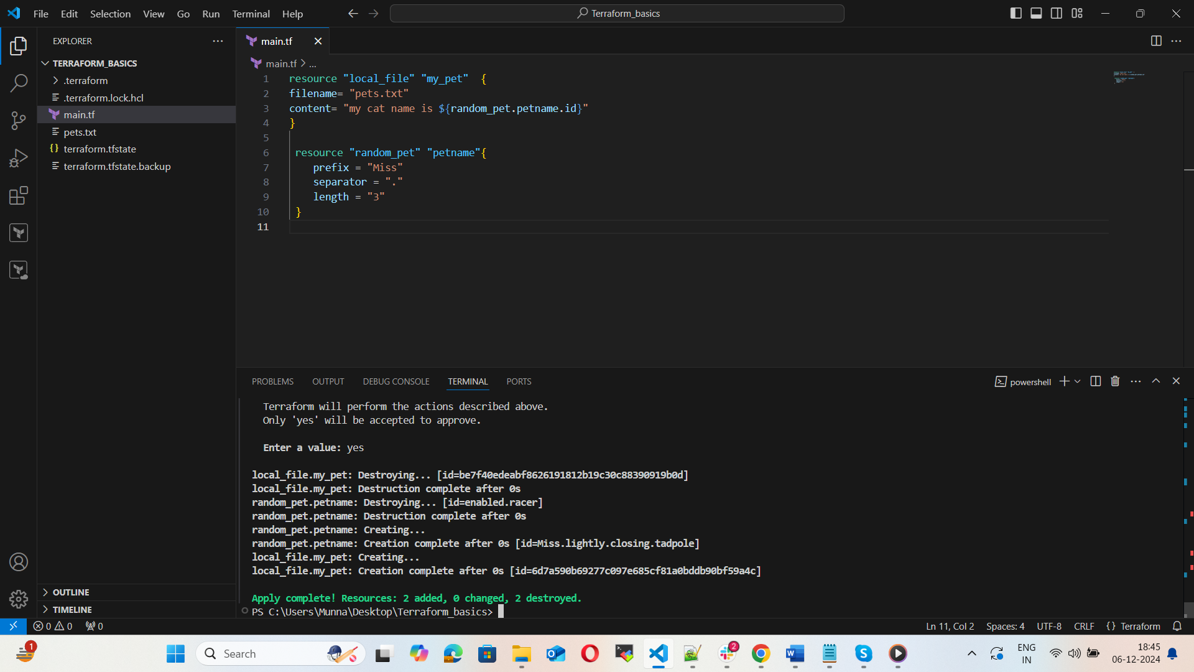

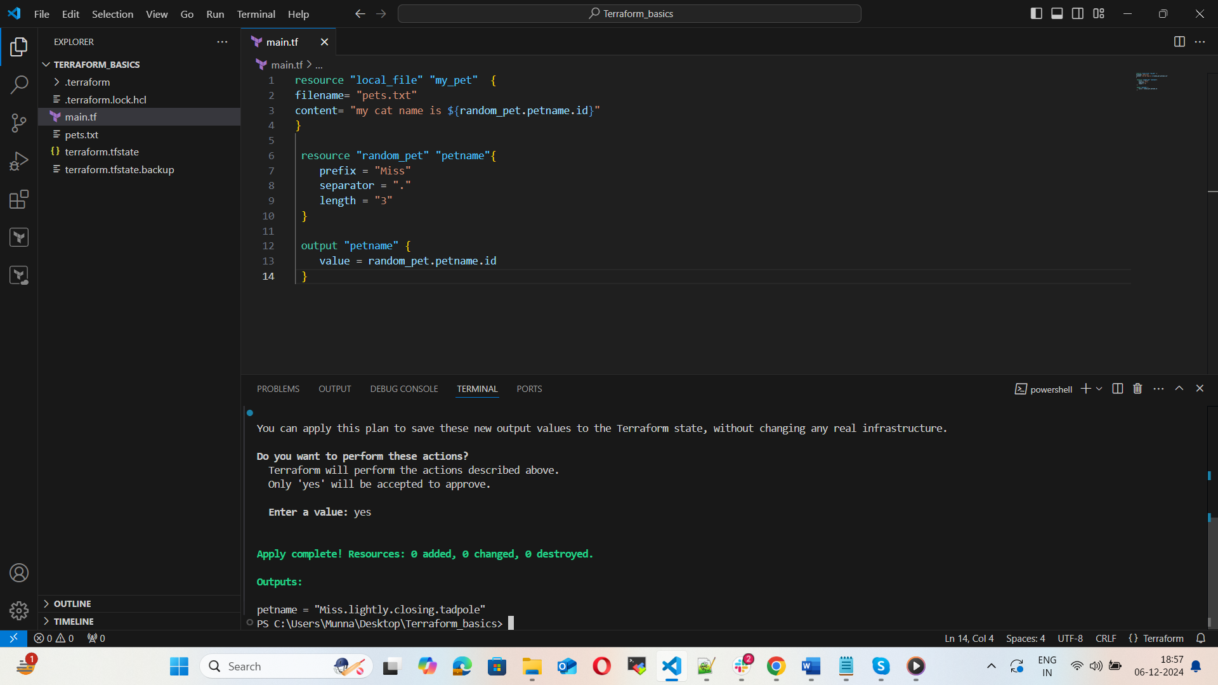

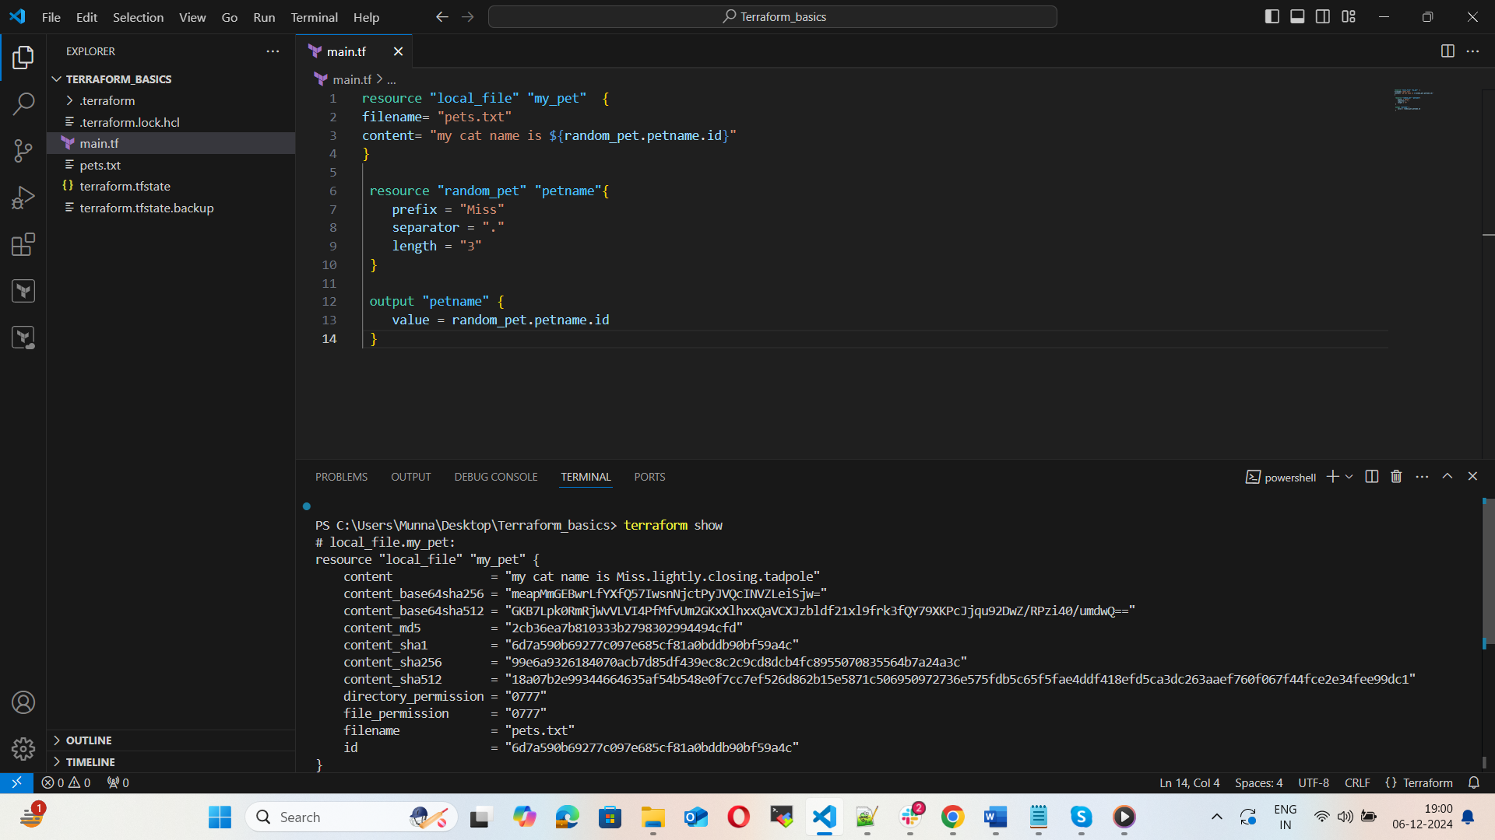

3) Integrate terraform in Jenkins using Terraform plugin.

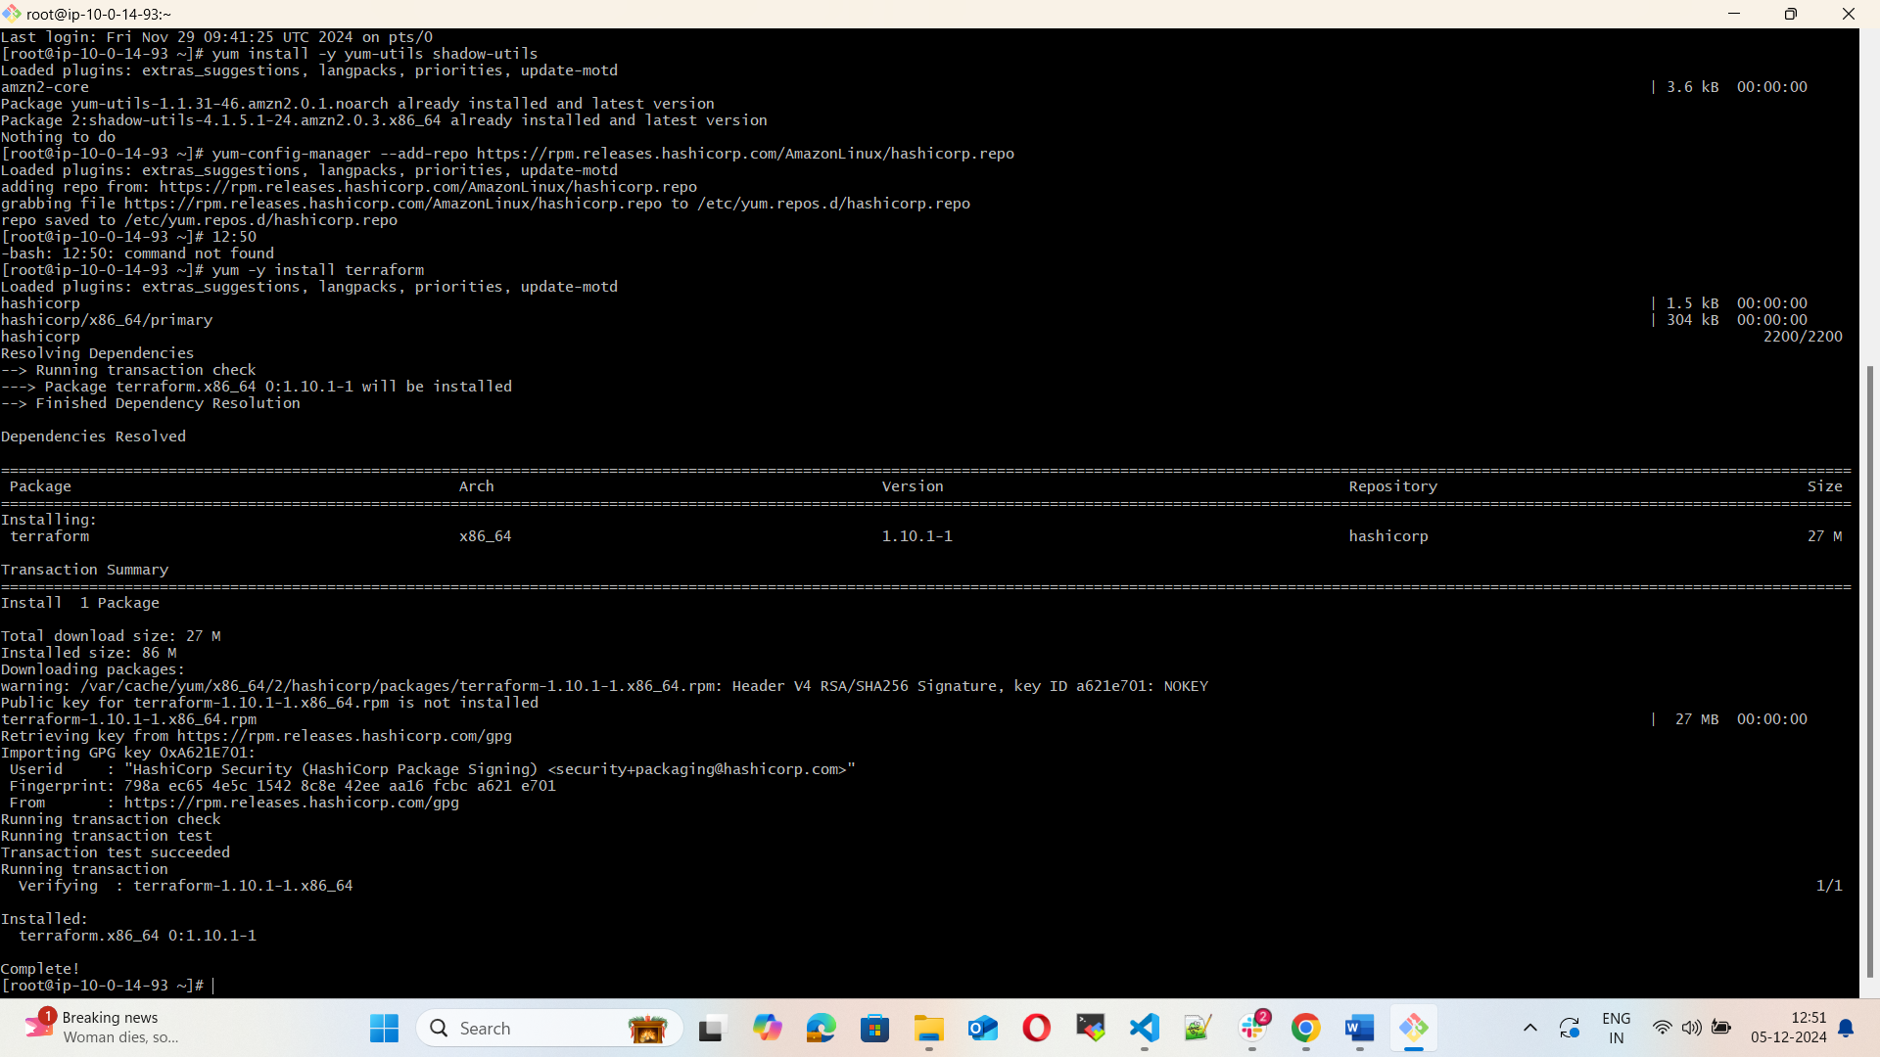

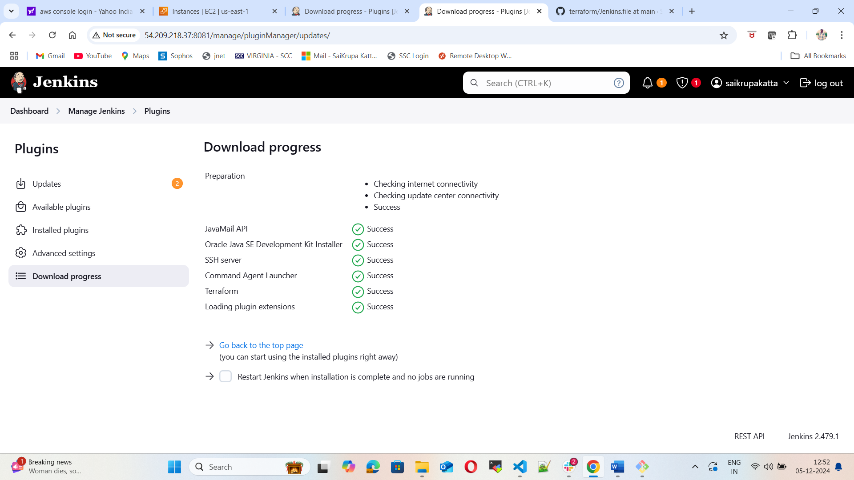

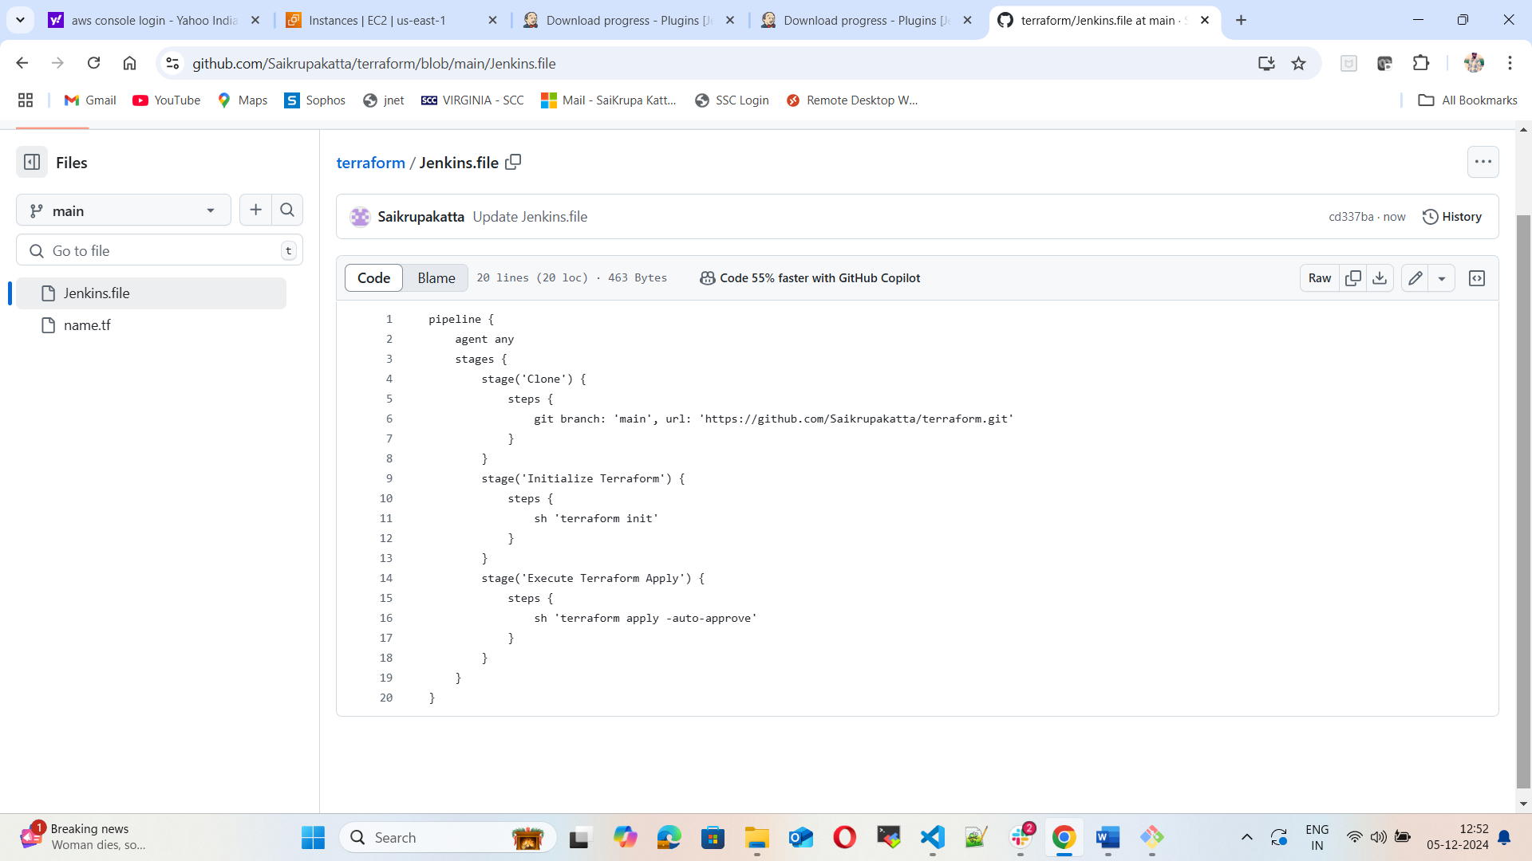

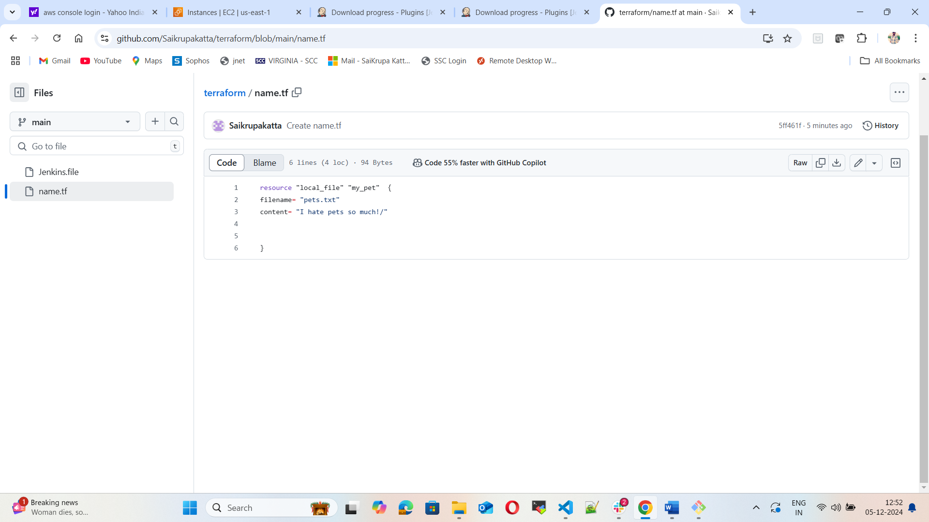

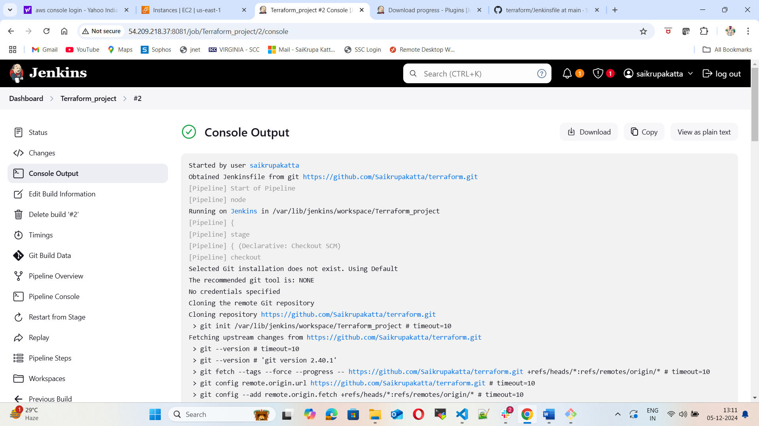

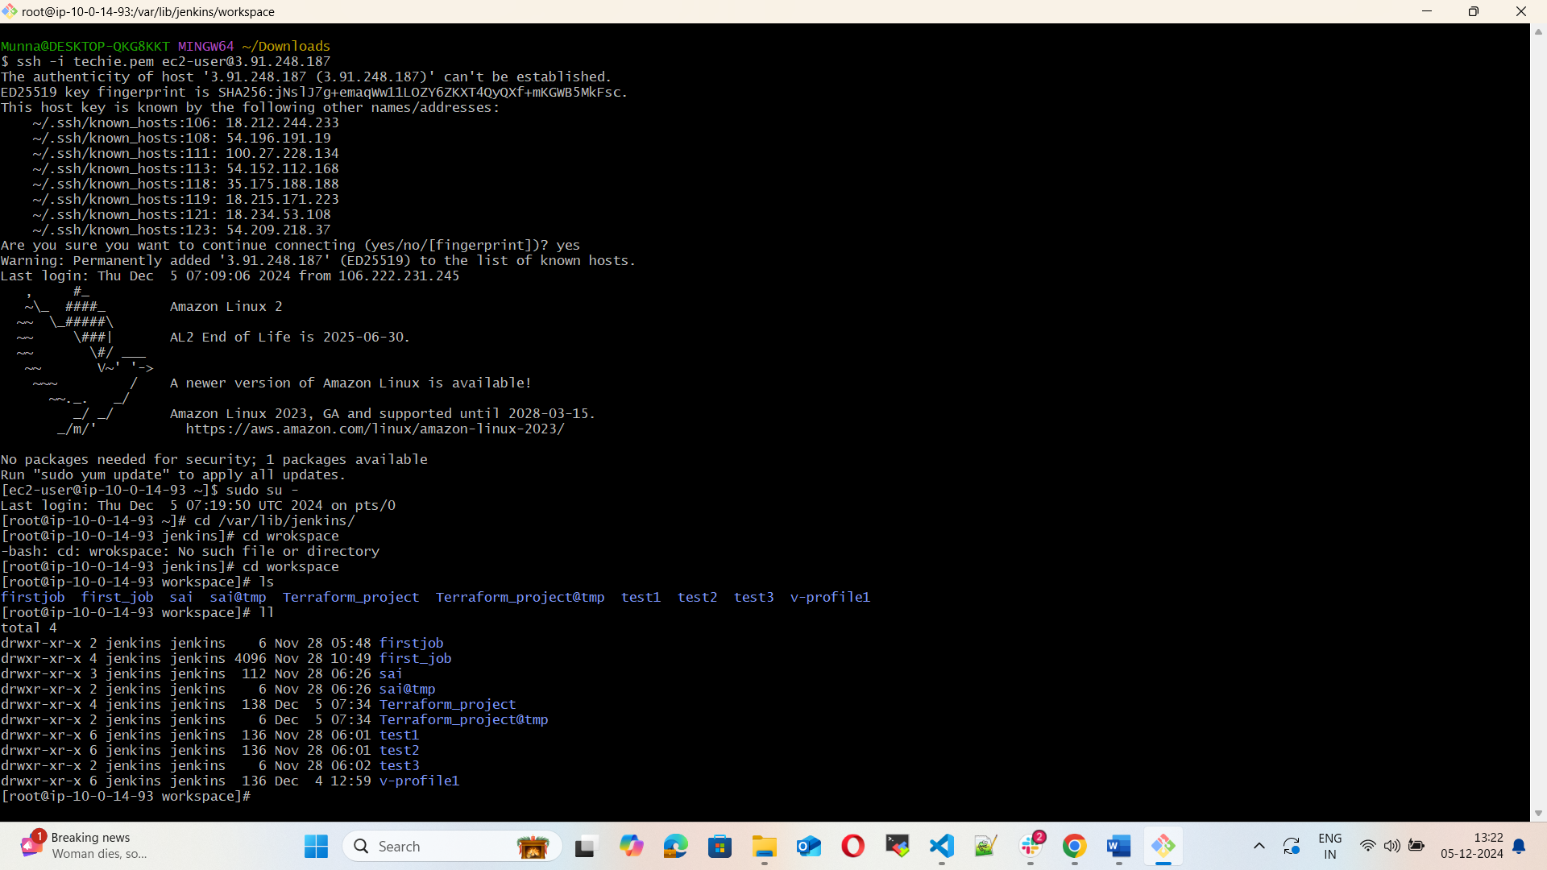

4) Create one Jenkins job using MAVEN PROJECT for the below code with two stages.

stage 1: Git clone

stage 2: Maven Compilation

Code: https://github.com/betawins/java-Working-app.git

5) Use the below code and create a parameterized job in Jenkins

stage 1: Git clone

stage 2: Maven Compilation

Code: https://github.com/betawins/java-Working-app.git

6) What are the global variables in Jenkins?

7) Watch terraform-04 video.

8) Execute the script shown in video.

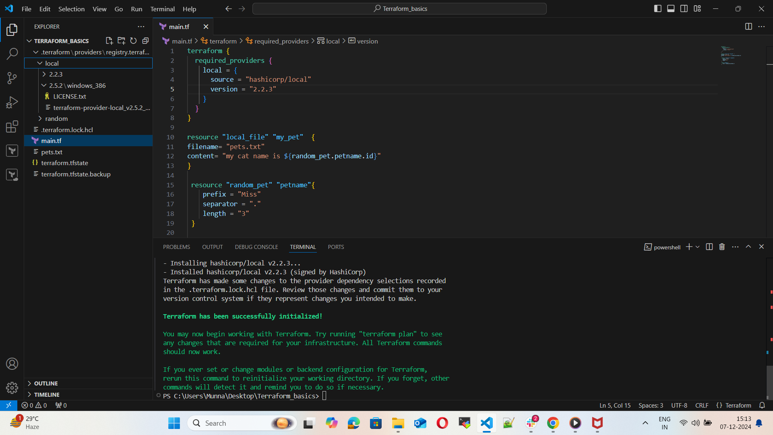

9) Integrate terraform in Jenkins using Terraform plugin.

10) Create CICD pipeline for Nodejs Application.

https://github.com/betawins/Trading-UI.git

11) Explain 10 Maven commands.